**Advance Excel Assignment 13**

1. Find the Minimum Marks and Maximum marks scored by each student from the below data.

Ans. 240418

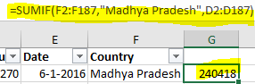

1. What is the total count of stationary bought from Tamil Nādu?

Ans. 13

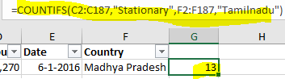

1. What is the total amount spent on footwear?

Ans. 194226

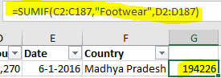

1. What is the total amount of money spent for stationary in July?

Ans. 67565

1. What is the count of footwear that is coming from Delhi?

Ans. 2

